**MERN Final Project:**

1. *Guest / Login User*

Guest will be shown different Nav bar with few links and home page on <http://localhost:4200/>

Logged in User will be shown these below Nav links (profile, Logout links will be additional)



Home Page will have Carousel (default), Categories (3 random Categories) and Top Selling Products (random 8 products)

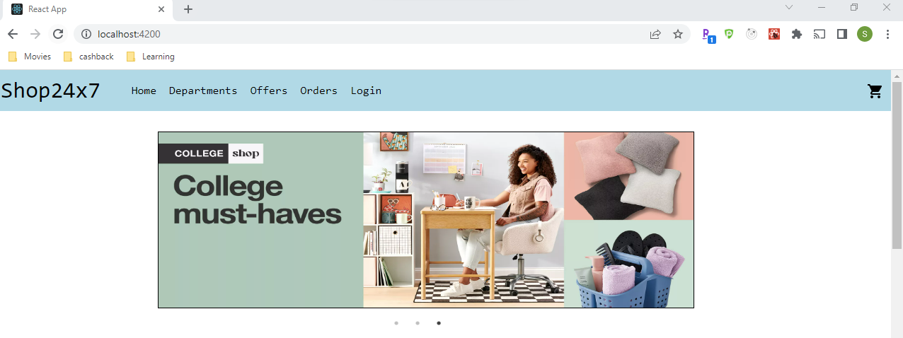



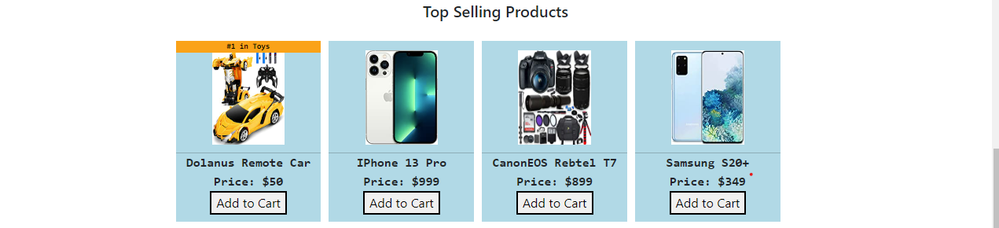

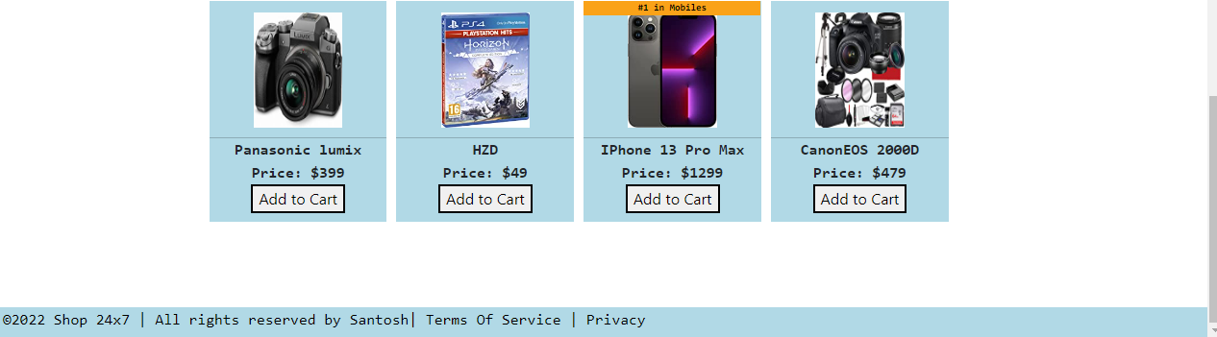

Top Selling Product will be shown with tag #1 in <Category Type>

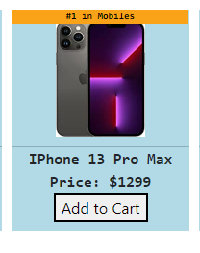

Departments Page – Guest / Logged in User can browse products by Categories <http://localhost:4200/Department> 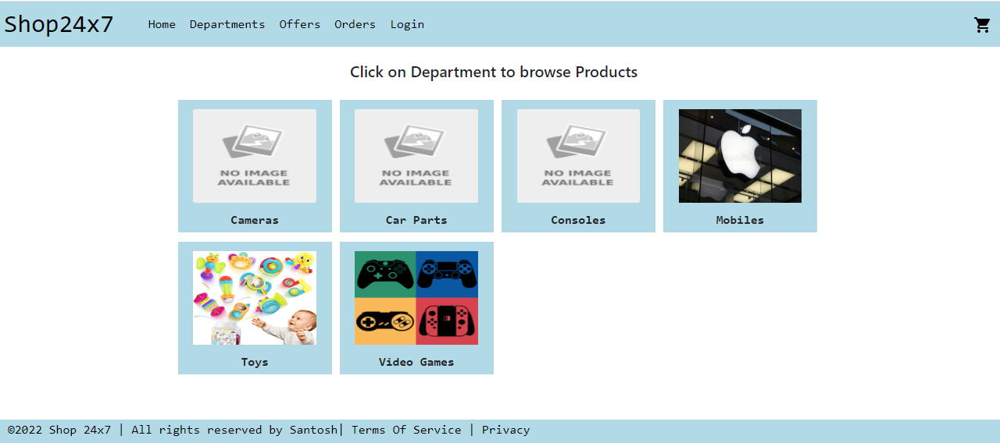

Products Under Category - <http://localhost:4200/Categories?categoryName=Mobiles>

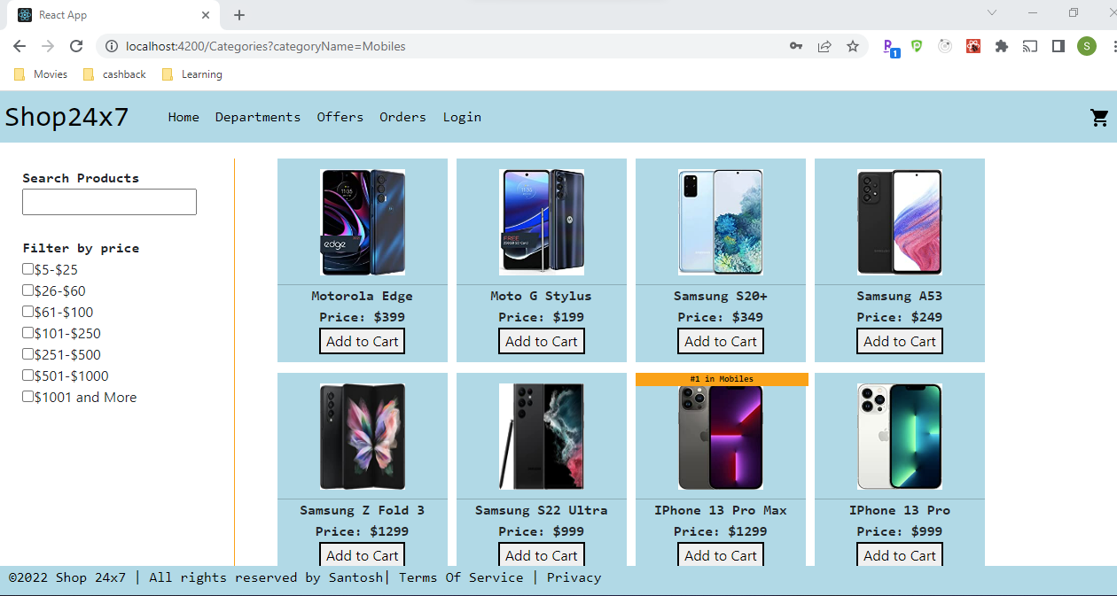

Filter by Price and Search

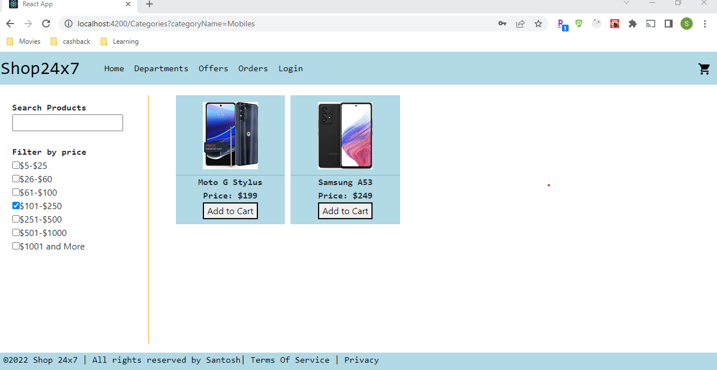

Search

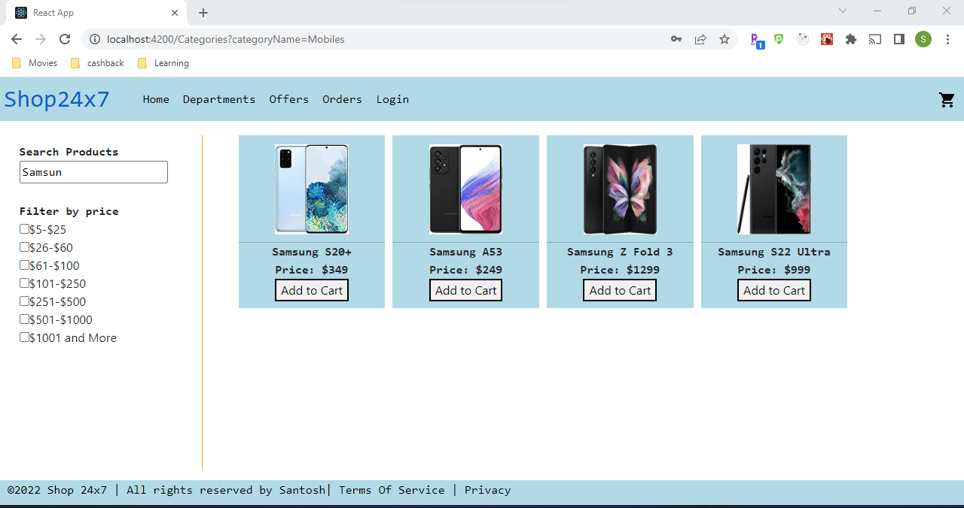

Cart Count will be updated automatically by adding products

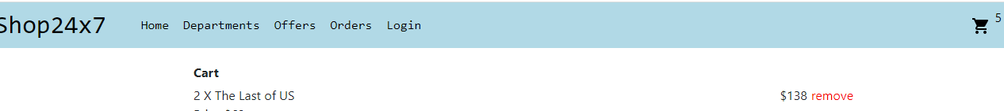

Cart Page - <http://localhost:4200/Cart>

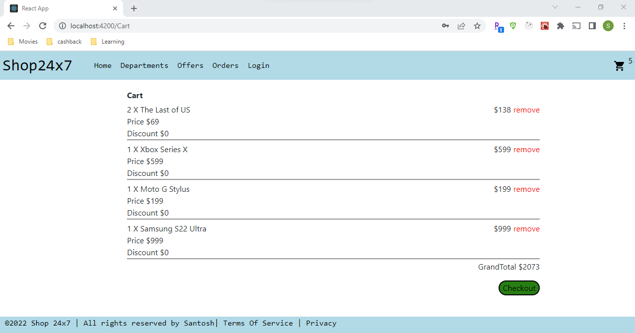

Products can be removed from Cart by clicking on remove button. Updated Cart after removing 2 products from above list

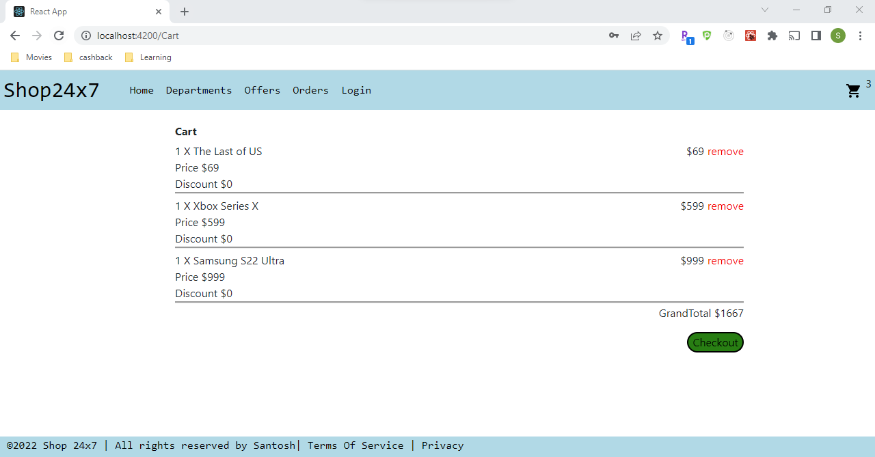

On Click of Checkout Guest will be redirected to checkout page to provide user information and shipping address

<http://localhost:4200/checkout>

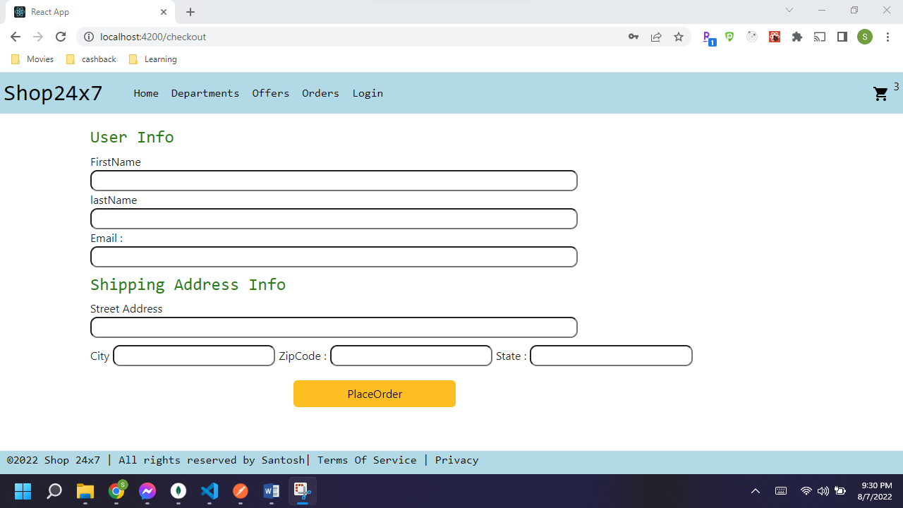

Validations:

Guest user has to provide all user info else they receive error – “Please enter User details”

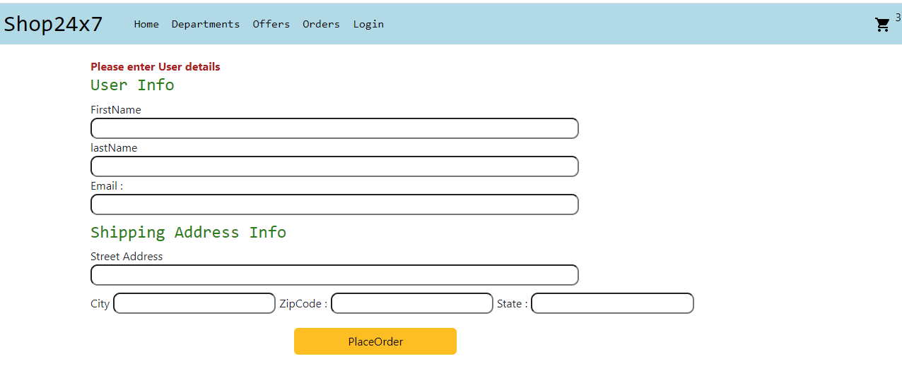

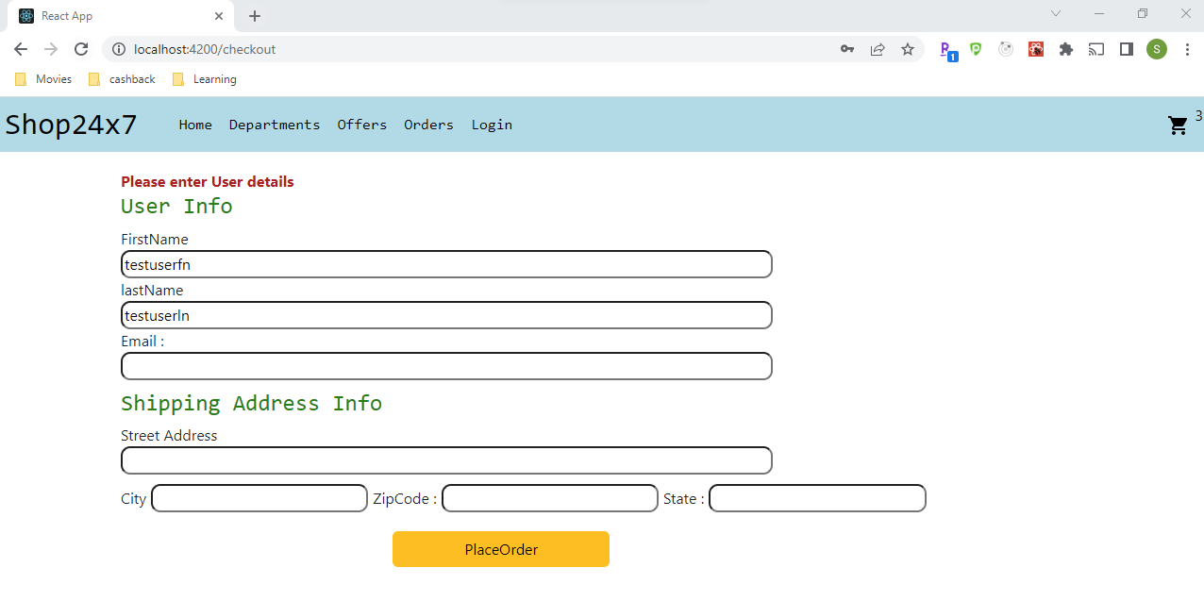

After user details entered Validations will be done for shipping address

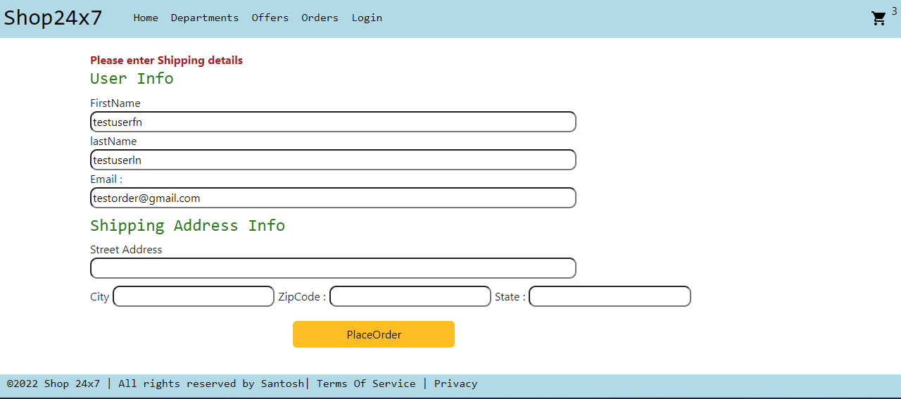

User will receive error message – “Please enter shipping details” until all fields are provided in Shipping info section

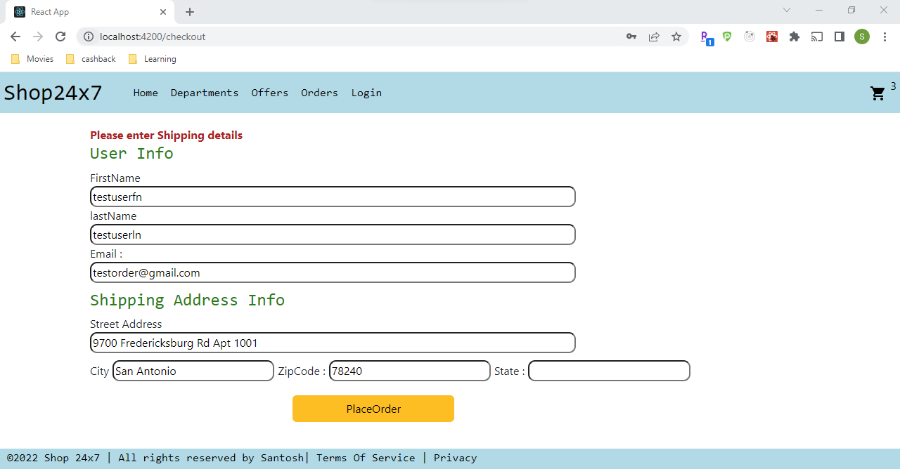

After Validations are success, Guest will be able to proceed further by placing order. <http://localhost:4200/orders>

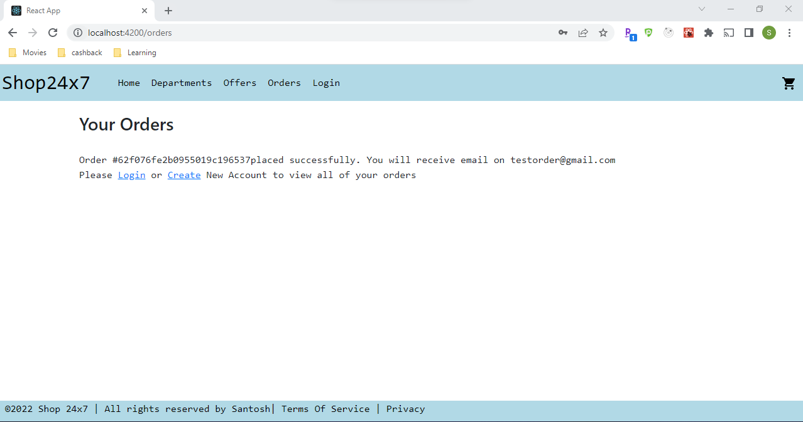

Guests will be shown message for the current order and also login or create account links on the orders page.